**UID LAB EXPERIMENT 10**

**Create a data visualization (e.g., pie charts, bar graphs) for an inventory management system using javascript.**

**SHERYL KATRINA.M**

**230701310**

**Aim:**

To create **data visualizations** such as **pie charts** and **bar graphs** for an **inventory management system** using **JavaScript** and **Chart.js** library.

**Software/Tools Required:**

* HTML5
* JavaScript
* Chart.js (via CDN)
* Any text editor (VS Code, Notepad++)
* Web browser (Chrome, Firefox, Edge)

**Procedure:**

**Step 1: Set Up the HTML File**

* Create a new file named index.html.
* This file will contain the structure of the web page and space (canvas elements) to display the charts.
* Also, we include the **Chart.js** library using a <script> tag that points to the CDN.

**Explanation:**

* <canvas> elements create blank areas where charts will be drawn.
* The external JavaScript (script.js) will fill these canvases dynamically with charts.
* Basic CSS styling is added to center everything nicely.

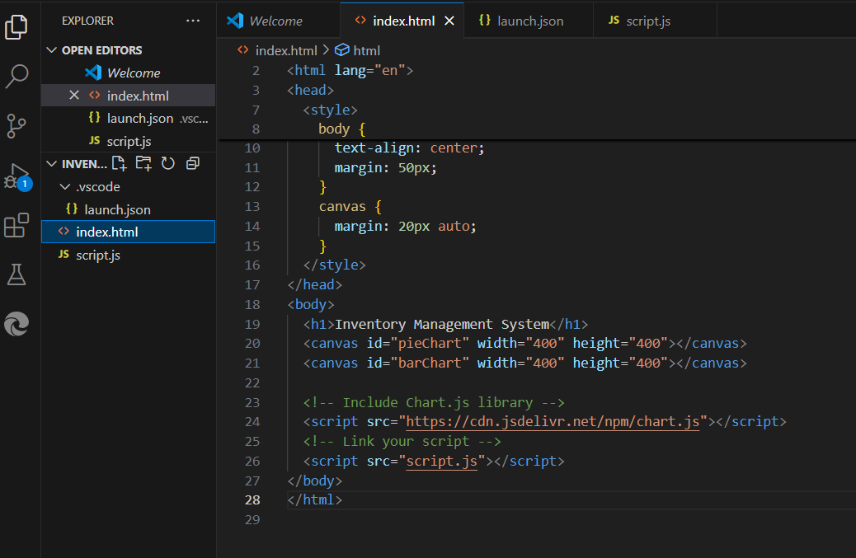

**Step 2: Create the JavaScript File (script.js)**

* Create a second file called script.js.
* This file contains the **logic** for setting up the data and drawing the charts.

**Explanation:**

* inventoryData object stores categories and their stock counts.
* Two different charts are created:
  + **Pie Chart** shows how the stock is divided among categories.
  + **Bar Chart** shows the exact number of items in each category.
* **Animations** (like bounce effects and hover enlargements) make the charts more interactive.
* **Tooltips** are customized to have dark backgrounds for better visibility.

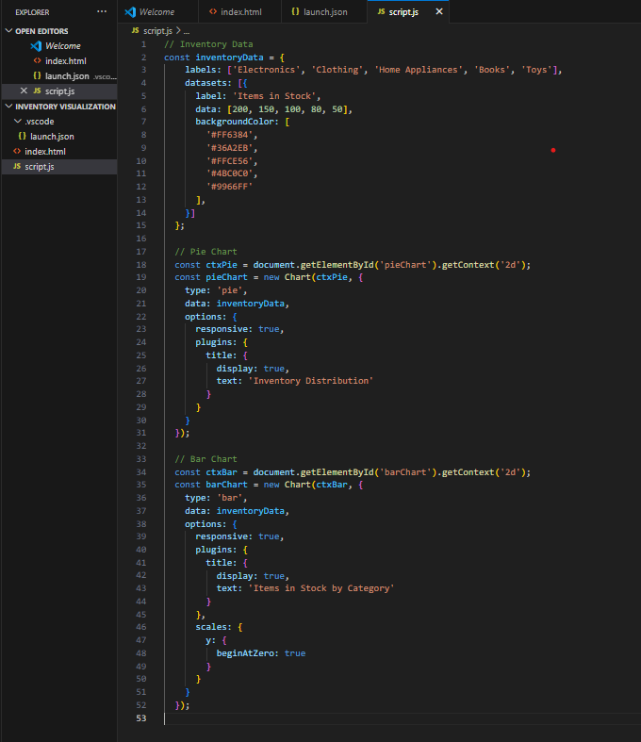

**Step 3: Run the Project**

* Save both files (index.html and script.js) in the same folder.
* Open index.html in any browser.
* You will see animated pie and bar charts representing the inventory stock.

**Output:**

Thus, we successfully created and visualized inventory data using pie charts and bar graphs with JavaScript and the Chart.js library, including customized animations and styling.

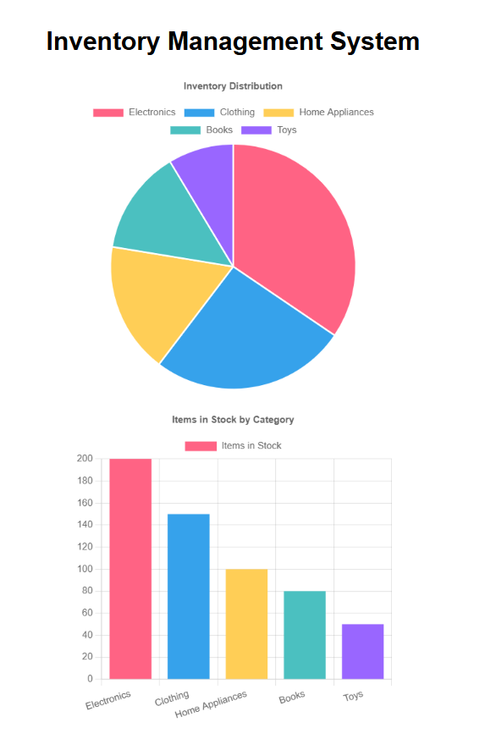

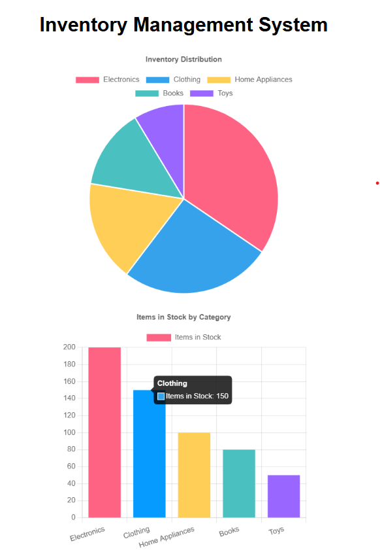

**Conclusion:**

In this experiment, we successfully designed an **interactive data visualization system** for an **inventory management application** using **HTML**, **JavaScript**, and the **Chart.js** library.  
By setting up the HTML structure, connecting an external JavaScript file, and using Chart.js functionalities, we were able to generate both **pie charts** and **bar graphs** that clearly represented inventory data.

We also enhanced the user experience by adding **animations**, **hover effects**, and **custom styling** for better visual appeal and easier interpretation of data.  
This project demonstrated the practical application of front-end web technologies for real-time data visualization, a skill that is widely used in dashboards, analytics platforms, and modern inventory systems.